**Name Manjinder Singh**

**ID**

**Title: Booking System**

# Section 1- Project planning and design

## Task 1 - Identify the problem

Indentified problem: they want to provide online booking for their customer to increase their experience and grow more.

While talking to Lovepreet Singh I indentify he is losing many customers due to no online booking at his store as all competitors are providing this faculty to their customers and now Lovepreet also want the same but with more security and features as their competitors giving.

## Task 2 -

### Scope of Work-

Provide a Website that can book the tickets and handle a record of customers and customer need to register to the website and then login to use to website.

### The features

As most of the customer base of watching movie is online so they prefer to search online and that’s why client’s major requirement is to provide SEO good site so that it could appear at the top of search results and client get this customer and more over it will provide all the features like Login and register and Booking a ticket.

### Functional Requirements

* Navbar on Top in working condition
* Every Link should Work
* Desired Result should open
* Prevent Crashing the software

### Non-functional requirements

* Very good SEO Work
* Fully Responsive up to any device
* Page Load Quick

## Time- Total projected time

### Cost -summary of total expenses

### Project management-

### 

### Risk management- Using

## 

## Task 3 - Design mockups

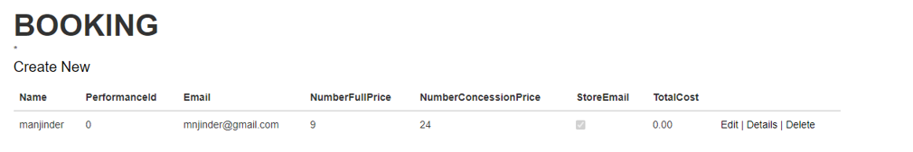

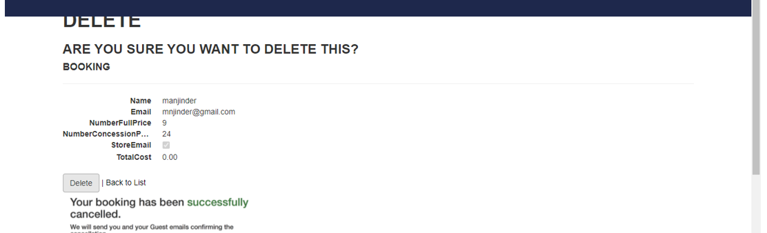

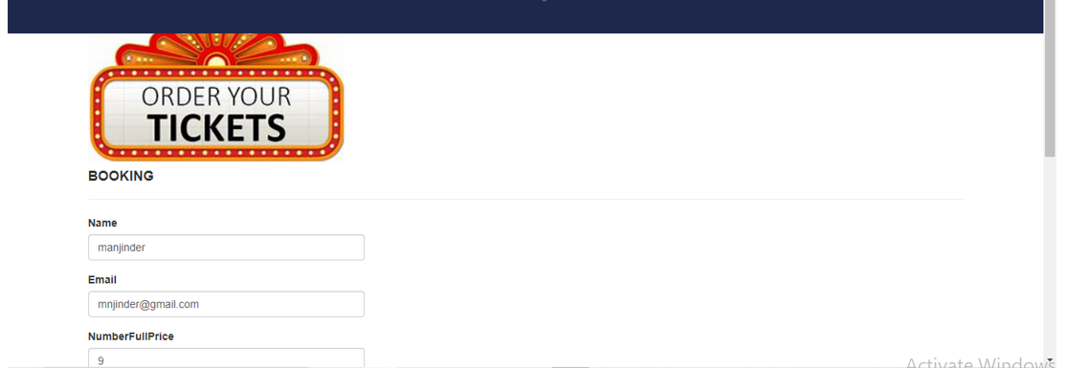

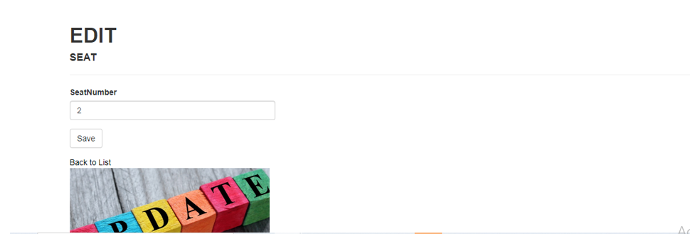

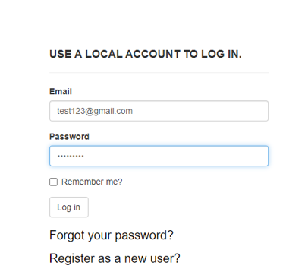

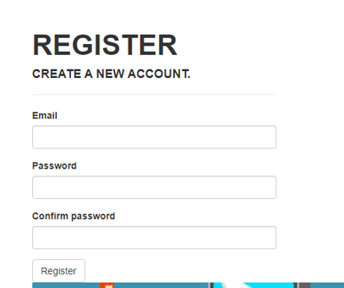

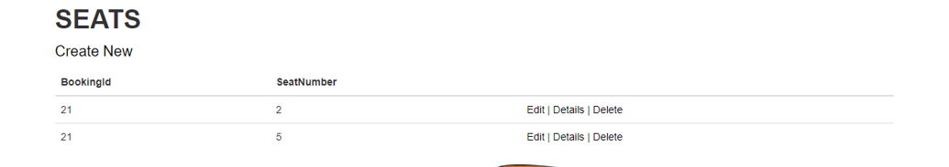

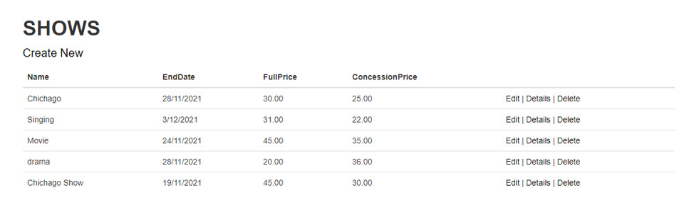

# Section 2 – Project development

## Task 4 – Coding

Is In Project Folder

## Task 5- usability testing

you should have all crucial tasks (minimum 3) and should have 3 participants

|  |  |  |  |  |
| --- | --- | --- | --- | --- |
| User | Task 1  *Search the product* | Task 2  *Add product to the cart* | Task 3  *Create a user account* | Comments |
| *User 1* | *Completed* | *Couldn’t find the icon* | *Completed* | *The icon visibility was poor* |
| User 2 |  |  |  |  |
| User 3 |  |  |  |  |

## 

## Task 6 - Meet with your client

Client Meeting:

|  |
| --- |
| Meeting Details |
| * Date and time: 29-Oct-2021 * Location: New Zealand |
| Attendees: Developer Manjinder Singh and Client Lovepreet Singh |
| Agenda: Booking system |
| Discussion (Important Points): Booking System Project Homepage and Login Logout and things to include in navbar i.e shows, performance bookings and seats |
| My To Dos (Actions): I my points about Database Tables and Columns |
| Questions requiring Follow- Up: Which tables to include in database |
| Comments: work to Link tables between each other |
| Next meeting  Date and Time: 1- Nov-2021 2:00 Pm  Location: New Zealand  Agenda: Discuss in detail about the database |

**Appendix 3**

**Client Review Form**

My developer’sname: Manjinder Singh

This form is intended to let you review the communication skills of your developer for this assignment. Your review will partly count towards their final mark. Do not take into account technical skills.

# Grading scale

You must grade your developer for each item listed in the tables below. 1 being the lowest, 5 the highest.

|  |  |  |  |  |
| --- | --- | --- | --- | --- |
| **1** | **2** | **3** | **4** | **5** |
| Strongly disagree | Disagree | Ok | Agree | Strongly agree |

# Review your developer

|  |  |  |
| --- | --- | --- |
| **Item** | **Grade** | **Comment** |
| Communicated clearly and effectively | 5 |  |
| Kept you informed of the progress | 5 |  |
| Met timelines | 5 |  |
| Responded promptly to problems | 5 |  |
| Met overall project objectives | 5 |  |
| Was open to new ideas and suggestions | 5 |  |
| Was easy to work with | 5 |  |

Comments

Provide any extra comments on your developer’s communication skills and professionalism.

Very Understanding nature and Work with Responsibility, it was a great experience working

Manjinder for the first time.

## Signed by Client

|  |  |
| --- | --- |
| **Signature: Lovepreet Singh** | **Date: 20-nov-2021** |
| **Name: Lovepreet Singh** | **Title:** Limelight Theatre Booking System |
| **Contact details (email/Tel):** | |

# Section 3– Presentation and reflection

Is Placed in Docs Folder

## Task 7- Presentation

Is Placed in Docs Folder

## Task 8 - Software development life cycle stages

Review your Software development life cycle stages

* Planning
* Requirement
* Software Design and prototyping
* Software Development
* Testing

## Task 9- Project management

# My Experience with Booking System Project

My experience was good working at this Project as it was my first project so lot of lot of happy learning moments happened which I captured in a good way and learned good lessons for the life like working in Professional and listening, working on client Work.

Booking System project was very big as it contains major two parts: One design and other development part. As it is client and user friendly site to so both part need some extra look over to work

## Difficulties:

Managing Time was difficult task for me firstly I started thinking that I won’t complete at time but at the end I manage to complete it at time.

Time: It was estimated to complete this project in 30-35 days but due the complexity in the project it took me 50 days to complete the project but it was competed with no errors and according to the client requirement.